International Health Care
Refugee Crisis
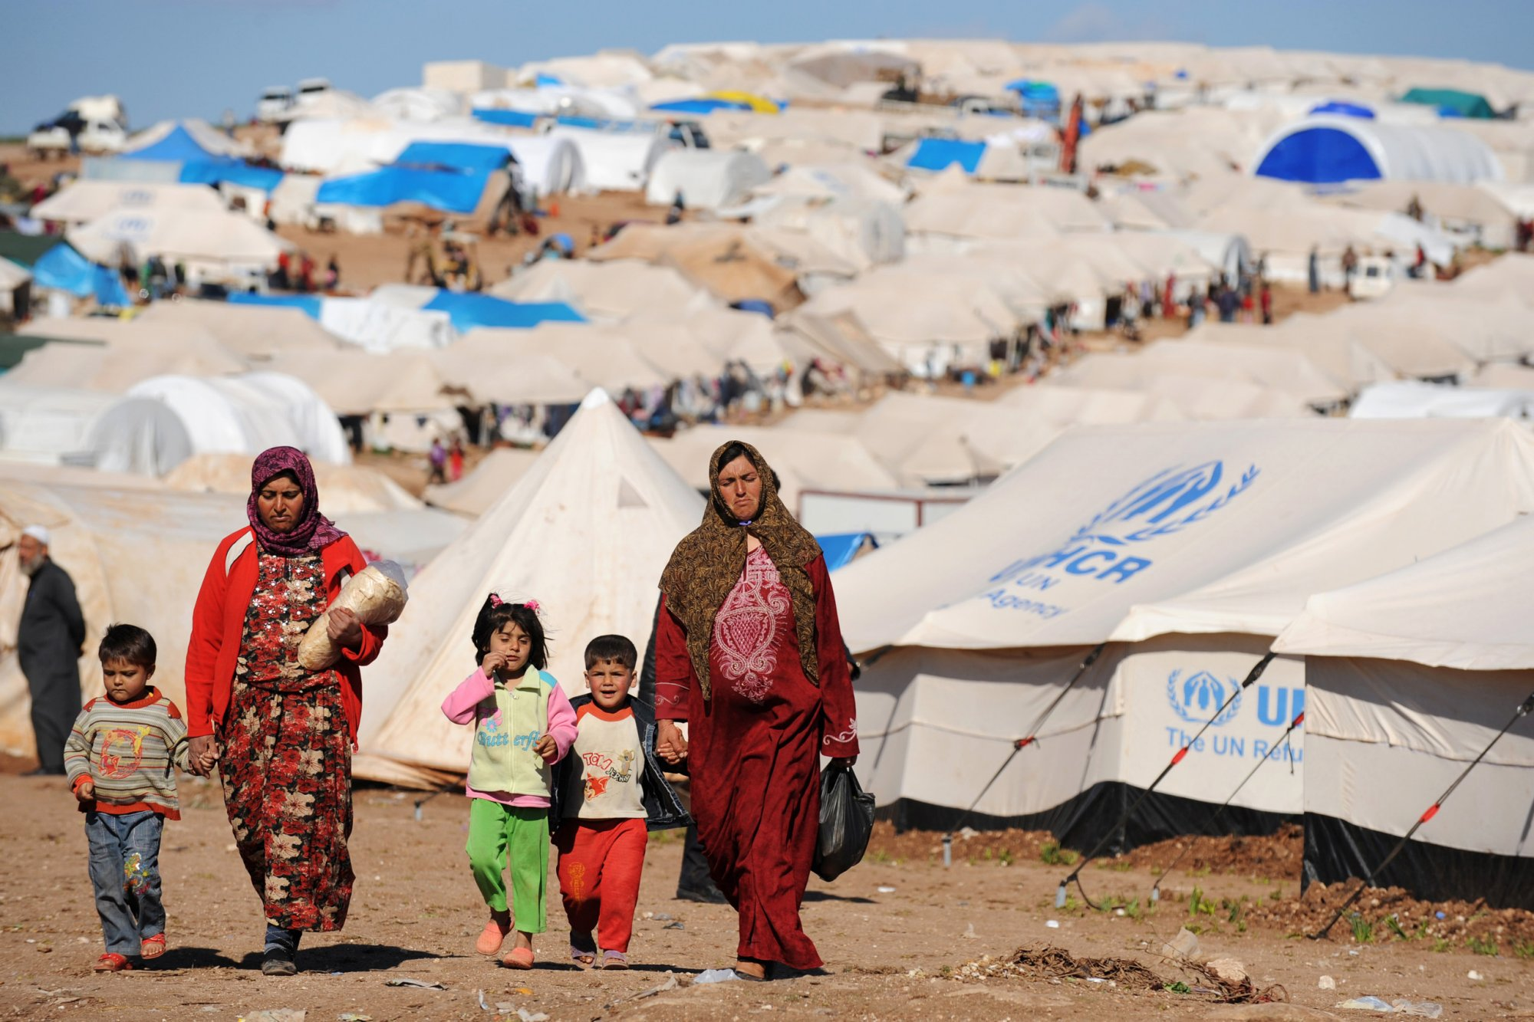
Refugees are people who are forced to flee their countries because of persecution, war or violence. Once these people cross an international border in search of safety, they create an international crisis as more than one government is now involved with their safety. The countries where these refugees seek asylum is often forced to ensure that these people have a safe place to stay and this may entail seeking help from other nations especially the powerful ones like the US and Russia. `the various countries who have given these refugees asylums have done a good job since taking in refugees is often viewed as a security threat since people terror groups may take advantage of such situations to infiltrate into neighboring nations by disguising themselves as refugees.
From the photo of the Syrian refugees’ camps, it is evident that most of the inhabitants of these camps are women and children who are often the most affected during the times of war. Life in this camp seems to be hostile, and from the look at the tents, it is clear that the quality of healthcare in these camps is not of high quality.
Citizens and refugees can be able to help one another to adjust to the new situations. This can be done by the citizens opening their arms for the refugee and stop stereotyping refugees as people who are looking for handouts and welfare. Once people have this type of mindset, then they will be able to realize that the refugees also bring in new opportunities since they increase demand for goods and services which in turn creates employment opportunities.
Response
I agree with you that it is important for citizens in the host countries to recognize that the refugees have nothing to do with welfare. They usually come out of their countries because of the hostility caused by war. It is therefore ill to think that they migrate to the host countries to seek for handouts. This is inhuman. Refugees want help and that is what they should receive from the host country. Many of them are usually educated and they are skilled. It is upon the host country to choose how to utilize the skills that the refugees have come with. They host country can seize the opportunity and employ them. In turn, these refugees are able to provide for themselves and support their families. It is therefore important to stop stereotypes, which may affect the refuges and make donors who may be willing to help them to shy away.

Works Cited
"CARE |." www.care.org/. "Trump considers using the U.S. military to establish refugee camps in Syria | SOFREP." sofrep.com/73303/trump-considers-using-u-s-military-establish-refugee-camps-syria/.

